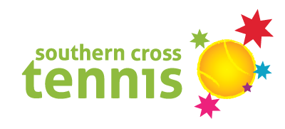

Eatons Hill Championship Links
Red Registration Link (Both Boys & Girls) https://www.classhub.com.au/secure/registration?providerAlias=southerncrosstennis&classId=3E18A383-2F9E-4A95-A168-92D50DEE03E1
Orange Junior Registration Links
BOYS:
https://www.classhub.com.au/secure/registration?providerAlias=southerncrosstennis&classId=D06EE284-821B-41BD-AD23-D01C16BFB7F6
GIRLS:
https://www.classhub.com.au/secure/registration?providerAlias=southerncrosstennis&classId=A402E0A2-EB81-4275-9C7E-FA11ADDF6C83
Green Senior Registration Links
BOYS: https://www.classhub.com.au/secure/registration?providerAlias=southerncrosstennis&classId=3473E763-B6F7-4E9E-BD62-773CCC837DBB
GIRLS:
https://www.classhub.com.au/secure/registration?providerAlias=southerncrosstennis&classId=08B014D0-F4CD-4272-AC7B-B451CF66BCCC

Samford State School Championship Links
Red Registration Link (Both Boys & Girls)
https://www.classhub.com.au/secure/registration?providerAlias=southerncrosstennis&classId=F270942D-6D0B-4A4F-A33C-902A0AF0A644
Orange Junior Registration Links
BOYS:
https://www.classhub.com.au/secure/registration?providerAlias=southerncrosstennis&classId=53509A03-188B-4DCD-B4BC-F9B9C46951D4
GIRLS:
https://www.classhub.com.au/secure/registration?providerAlias=southerncrosstennis&classId=8C907468-3D42-4590-BCC3-C30BA0276907
Green Senior Registration Links
BOYS:
https://www.classhub.com.au/secure/registration?providerAlias=southerncrosstennis&classId=D96E1C2A-7BAA-45C3-A5CD-0EB138CD92CF
GIRLS:
https://www.classhub.com.au/secure/registration?providerAlias=southerncrosstennis&classId=1650E959-8FC8-472D-8968-2E2781A46D97

